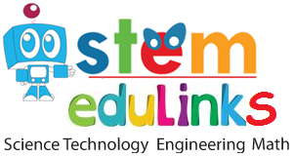
Phone: +61 (0) 872268626, +61 (0) 420247594
Email: info@stemedulinks.com Webpage: www.stemedulinks.com
-----------------------------------------------------------------------------------------------------------------------------------------------------------------------

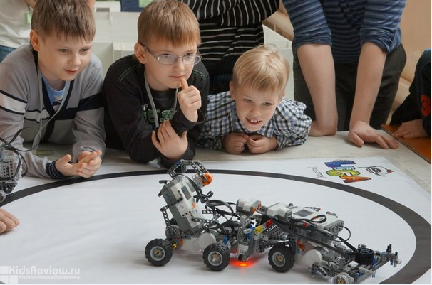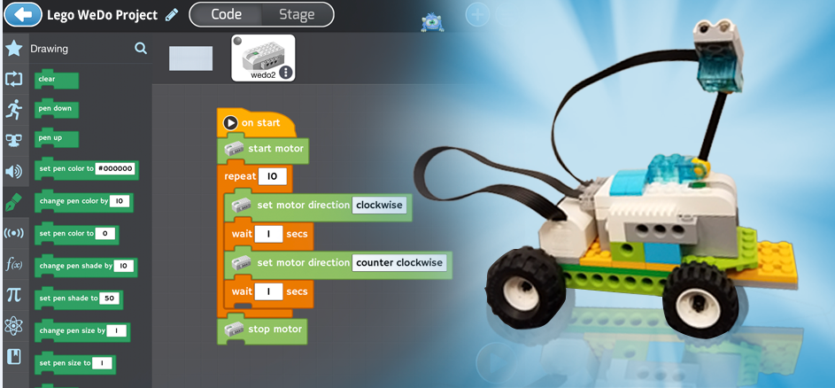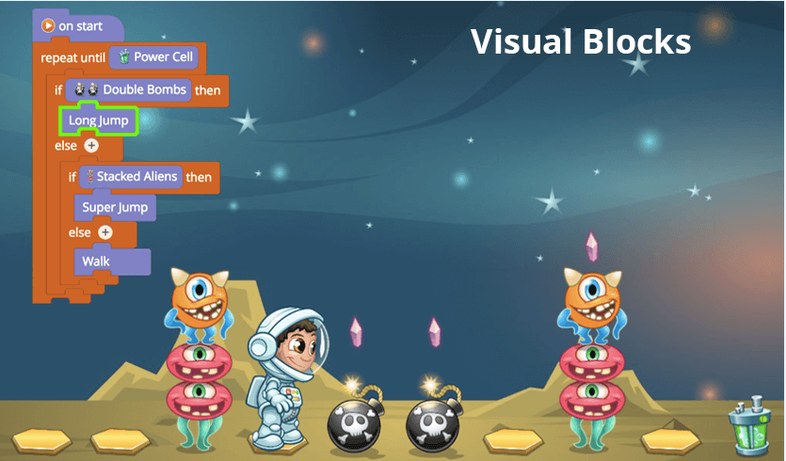

Dear Parents / Caregivers,

Kids are growing up in a very different world than that of their parents. Smart phones, computers, YouTube, Netflix, and Facebook are embedded in their daily lives. Even toys are digital, and many are programmable, such as Lego and the new-generation Leap Frogs.
It is one thing to know how to use these technologies. It’s another, however, to understand the logic behind them. When learning to program, kids understand Game making and Robotics with the digital world they inhabit. Coding draws back the seeming “magic” of technology so they can truly understand the logic and science that controls this technology – a discovery that is all the more magical.
Our reliance on technology will only increase. The students of today must be able to not only passively consume this technology, but also understand and control it, becoming an active part of this huge digital shift.
At Stem Edulinks, from 4th February 2018, we are introducing our next After School program for Computer Coding and Robotics. Through this course Students will learn Java Programming Concepts, Problem solving skills & Engineering Concepts.

Videos of Term 4 2017, After school program at Unley Primary School.
https://www.youtube.com/watch?v=x4ecOPP_lmo
https://www.youtube.com/watch?v=QUoP82IWY5g&t=2s

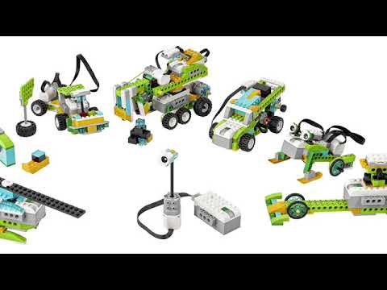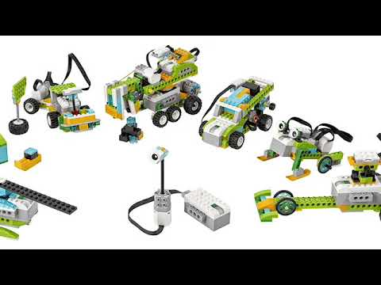

Details of Course:

2) Course 01 - Computer programming & Game Making (Followed by Mobile app making in Term 2) | Course 02 - Robotics (Robot build & Programming)
Students will learn:  - Statement Sequencing & Circular Links  - How to Create variables and if-else statements  - Program using arithmetic operators  - Design and animate sprites  - Experiment and explore to build creativity and confidence  - Mathematical Concepts | Students will learn:  - Explore Visual Programming with WeDo 2.0 and Mbot  - Build robot that use Motors, Sensors and extensions  - Program and utilize multiple sensors  - Develop structural design skills  - Science and Engineering Concepts  - Documentation of projects
Projects of first term:  - Mr. Bit Maker (2D Model)  - Rock Paper Scissor with Java blocks  - Fire Flies  - Coin Flipper  - Story Telling  - Animation Games | Projects of first term:  - Milo with Science Rover, Motion Sensor, Tilt Sensor and Collaborate  - Spirograph generator  - Drop and rescue Helicopter  - Air Plane Launcher  - Air Traffic Radar

Student will take home: Project files | Student will take home: Project files
Couse Duration: 10 weeks (once a week)  Class Duration: 1.15 hour per class  Lesson Day & Time: Monday, 3.45 PM to 5.00 PM PM  Venue: Computer Room, Unley Primary School.  Course Fee: $200 (Onetime payment for 10 classes) OR $25 per class | Couse Duration: 10 weeks (once a week)  Class Duration: 1.15 hour per class  Lesson Day & Time: Thursday, 3.45 PM to 5.00 PM  Venue: Computer Room, Unley Primary School.  Course Fee: $200 (Onetime payment for 10 classes) OR $25 per class

Enrolment Process:

For enrolment, please email / sms the following information at info@stemedulinks.com / 0420247594.

Enrolment for (Course 01 / Course 2 / both)
Name of Student:
Class Room No.
Name of Student’s Parent:
Email of Student’s Parent:
Phone No. of Student’s Parent:

Thanks & Regards
Mukesh Mittal
Executive - Leaning & Development
Stem Edulinks

